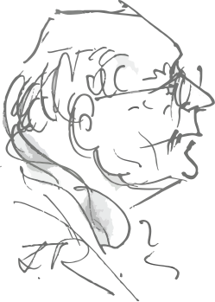 | OOM GAWIE EKSTEEN  HOUTWERK  Kleinmond  Email:gawiejeksteen@gmail.com  Cell: 0824999903  www.oomgawie.co.za | PRYSLYS  8 MAART/8 MARCH  2024  PRICE LIST

BESTELVORM/ORDER FORM
ARBEIDSTERAPIE APPARAAT/OCCUPATIONAL THERAPY APPARATUS

Name/Naam | E-mail/Epos
Address/Adres
 | Cell/Sel

WOOD/HOUT ITEMS | # | R
Balance board/Balans bord 1100 x 550mm⁽³⁾ |  | 1 000
Balance beam/Balans balk 2100x115x50mm |  | 1 800
Incline board/Skuinsbord A3 |  | 380
T-stool/T-stoel 300x300x300 mm |  | 250
Scooter 600x380 mm |  | 750
Scooter 450x300 mm |  | 650
SWINGS/SWAAIE |  |  | Red/Rooi | Blue/Blou
Bolster^{x1} 1100x200 mm φ |  | 2 000
Flexion^{x1} 600 mm φ |  | 1 700
Glider^{x1} Platform 1100x550 mm |  | 1 900
Frog swing/Paddaswaai^{x2} |  | 800
Trapeze 550 mm |  | 150
REPLACEMENTS/VERVANGINGS |  |  | Red/Rooi | Blue/Blou
Bungee cord/rek |  | 130
Bolster |  | 160
Flexion |  | 90
Gliders/Platforms |  | 160
NOTES/NOTAS
1 Apparatus must at all times be used under strict supervision of a Therapist. Apparaat moet te alle tye onder streng terapeut toesig gebruik word.
2 Other OT apparatus will be considered on request/Ander AT apparaat sal op versoek oorweeg word.
3 Dimensions may vary slightly/Afmetings mag effe verskil.
4 Standard Courier cost to Cape Town R180./Standaard Koerier koste Kaapstad R180.
5 #Number/Hoeveelheid φ Diameter/Deursnit
6 Limited stock is kept. Beperkte voorraad word gehou
All items are handmade and may take Alle items is handgemaak en mag neem tyd.
time
^{x1} Foam padded, vinyl covered/Spons bedek met Viniel oorgetrek.
^{x2} Foam padded PVC covered/Spons bedek met PVC oorgetrek.
^{x3} Rubber mat (2mm) covered/Rubber (2mm) oorgetrek

HANDTEKENING/SIGNATURE: ……………………………………………….

BANK: GJ Eksteen Nedbank 107110 Acc/Rek 1071 336 282.

